Project Report
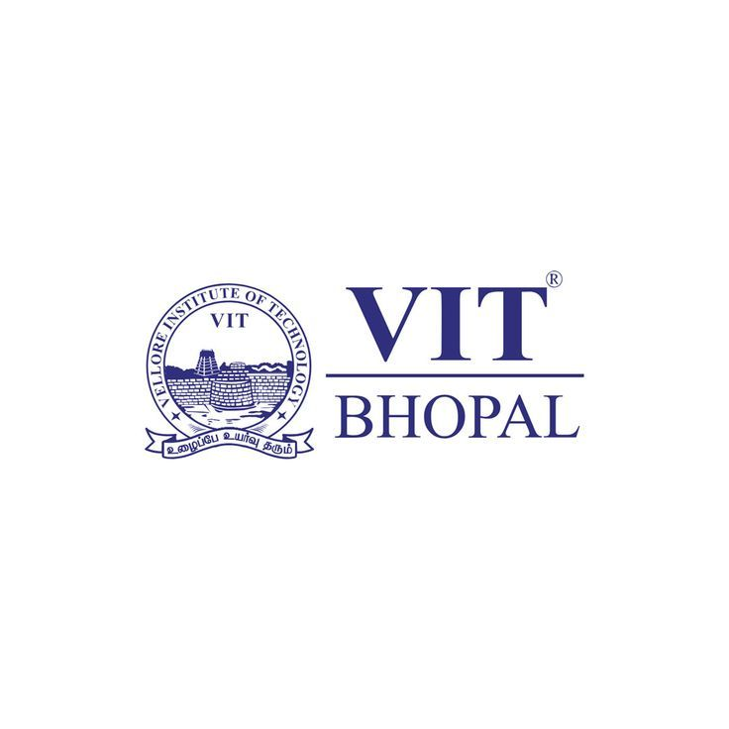
Name – Shreya Gupta
Registration no – 25BET10052
Branch – CSE( Education Technology)
Year – First Year
Course Code- CSE0001
Date – 31/03/2026

Introduction
For my first major assignment as a student at VIT Bhopal, I was appointed to the role of Student Digital Ambassador. The goal of this project was to move beyond just using technology and instead focus on mastering "Digital Literacy" as a professional skill. Throughout the five tasks, I worked on building a digital identity that represents me well to both my professors and future. Throughout the project, I completed several tasks that improved my practical knowledge of online platforms, communication, drafting an email and cyber safety.

In Task 1
In this task, I have created a digital infographic using the tool Canva and through the infographic I have present the important topics of digital literacy in clear and visually appealing format. I decided to focus on four main pillars: a simple definition of digital literacy, safe internet habits, professional email etiquette, and useful digital tools like GitHub and LinkedIn.
Reflection
While making the infographic, I learned how to arrange information in a simple and attractive way. I also understood how colours and visuals help make content easier to understand. Overall, this task improved my creativity and presentation skills.

In Task 2
In this task , I have created my digital presence on professional platforms like LinkedIn , GitHub and Kaggle .
Platforms Set Up:
GitHub - Used for hosting code and projects. Created a profile README that shows on my profile page with my name, branch, year and learning goals.
LinkedIn - Professional networking platform used by recruiters and companies worldwide. Added my education details at VIT Bhopal University, B.Tech Computer Science,
Kaggle - Data science and machine learning community where students can practice coding, participate in competitions and access datasets. Useful for CSE students.
The purpose for creating profile on these platforms is that platforms like LinkedIn help me to build connections through all over the world and GitHub help me to upload all my coding projects and at last Kaggle will allow me to practice on datasets and participate in competitions

Over the next four years, I plan to use these platforms to document every major project I work on, ensuring that by the time I apply for internships, I already have a solid portfolio of work ready for recruiters to see.

In Task 3
In part A, I have explored tools that are necessary for coding practice and team projects. I started by creating an account on platform Hacker Rank and using my basics of python knowledge I have solve challenge. The problem required reading two integers from standard input and printing their sum — a foundational exercise that tests whether the user understands input/output in a programming language This is a great way to get familiar with how competitive coding platforms work. Moving forward, I decided to use Hacker Rank regularly to improve my problem-solving skills.

In part B, I have created digital awareness Quiz using google form. This was an interesting task because it allowed me to design my own Questions and understand how Quizzes and survey are created digitally. While making quiz, I learned how to structure multiple-choice questions and ensure that the questions were meaningful and related to digital safety topics.

In Task 4

In part A, I practiced formal email writing by drafting two specific emails in which one asking for an assignment extension and another expressing interest in an intership . Writing these helped me understand the importance of clear subject and respectfull tone and polite closing statement and how should we convey our message to other person .

In part B , I have prepared a social media Do’s and Don’ts checklist . I realized how it is important in now-a-days to use social media safely and careless use can lead to privacy risk and misunderstandings. Through the checklist we can remind ourselves that what we post online can have long term effect on our careers.

Key learnings
Through Task 4, I understood how important it is to maintain professionalism while sending emails. I learned how small details like proper formatting and respectful tone can make communication more effective. And in the social media do’s and don’ts also made me more aware of how careless posting can create problems. This task helped me become more careful and responsible while communicating online.

In Task 5
In part A, I developed a detailed case study on UPI/Online Payment Fraud, This task was particularly important because it increased my awareness about online financial frauds that are becoming very common today. While writing the case study, I understood how fraudsters trick users into sharing sensitive information or approving fake payment requests. I also learned about prevention measures such as not sharing OTPs, verifying payment requests, and reporting fraud incidents to the appropriate authorities. This task helped me understand that digital awareness is not only useful but also necessary for personal safety.

In part B, I made prevention checklist that will help us to stay safe online. This checklist contains 8 tips which is very useful such as never sharing a PIN to receive money and use 1930 national helpline for reporting these case or online fraud.

What Surprised Me:
While working on the case study, I was surprised to learn how easily cyber fraud can happen and how fraudsters trick people using simple methods like fake links or payment requests. I did not realize that even small mistakes can lead to financial loss.

One Habit I Will Change:
One habit I will change is that I will always double-check links and payment requests before clicking or approving them. I will also avoid sharing personal or banking details with unknown sources to stay safe online.

Conclusion
Completing this project as a Student Digital Ambassador has been a transformative experience. I have moved from being a basic user of technology to someone who understands the importance of a professional digital identity, secure online habits, and effective communication. This project taught me that digital literacy is a continuous learning process. The skills I’ve gained—from managing a GitHub repository to identifying cyber threats—will be the foundation for my success over the next four years of my B. Tech degree and beyond.
References
• Canva – canva.com (Task 1: Infographic creation)
• GitHub – github.com (Task 2: Profile and repository setup)
• LinkedIn – linkedin.com (Task 2: Professional profile)
• Kaggle – kaggle.com (Task 2: Data science profile)
• Hacker Rank – hackerrank.com (Task 3: Coding challenge)
• Google Forms – forms.google.com (Task 3: Quiz creation)
• National Cyber Crime Reporting Portal – cybercrime.gov.in (Task 5: Reporting channel)

